Payment Gateway:

Assuming that the booking has been done and confirmed by the user

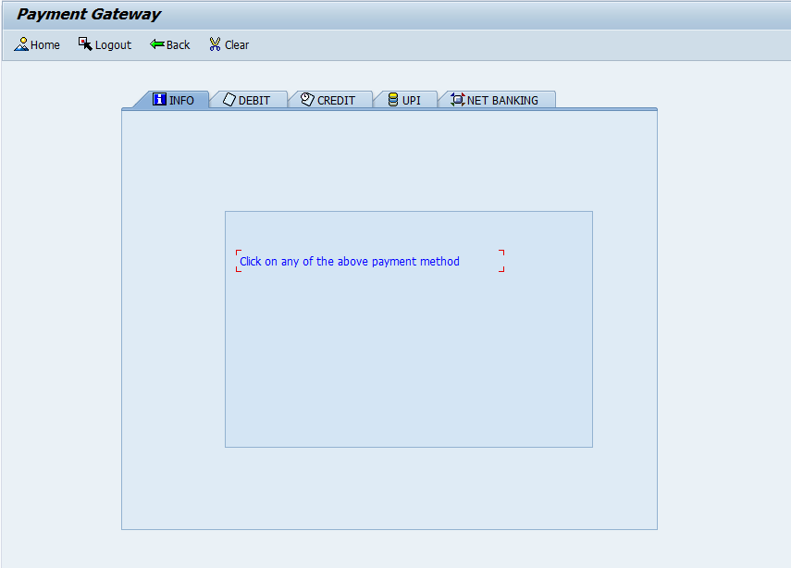

User has to choose any of the above displayed options on tab strip for his/her payment method.

For canceling he or she can press the logout push button.

Payment screens:

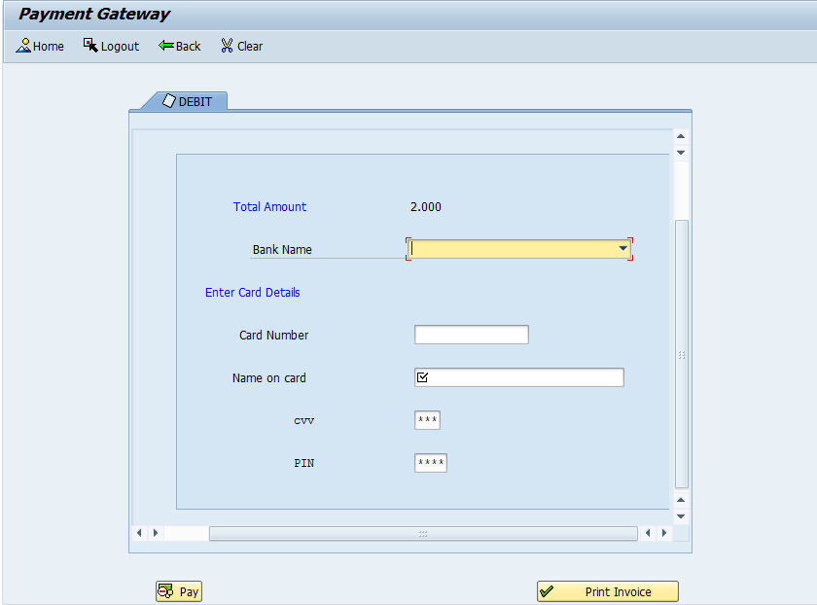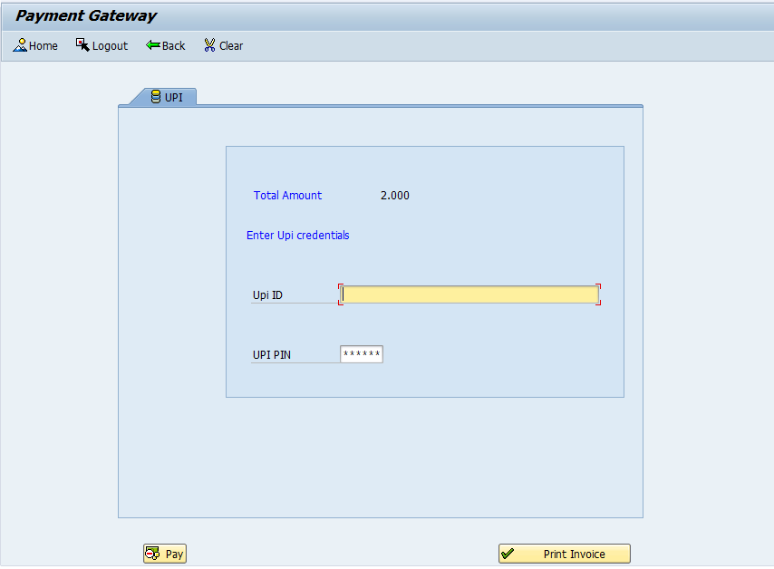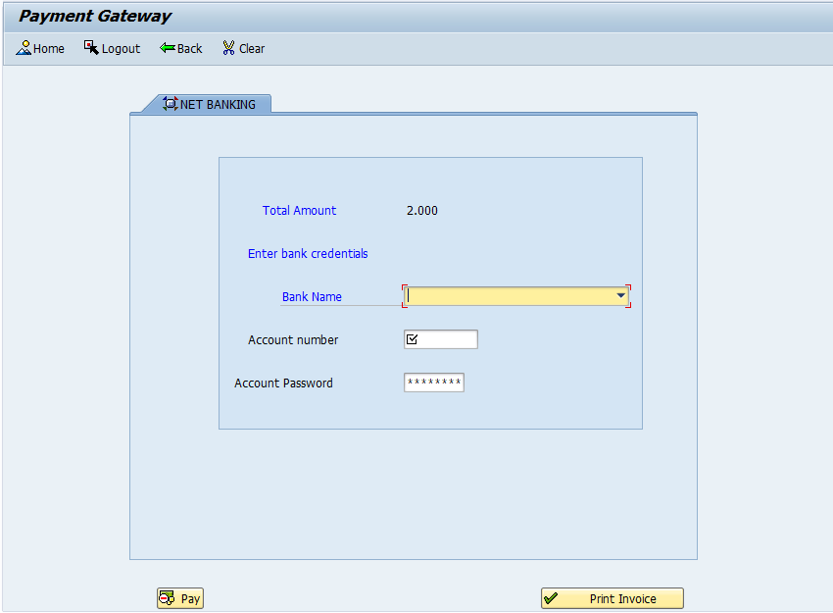

For example:

Once debit tab is chosen all the other tabs are hidden and pay as well as print invoice button becomes visible.



User can choose the respective field from the options.

Pending work:

Screen validation for fields except card number with the data base

Invoice:

Once user enters the correct credentials he gets a cue to choose print option. And the invoice is generated from the database.

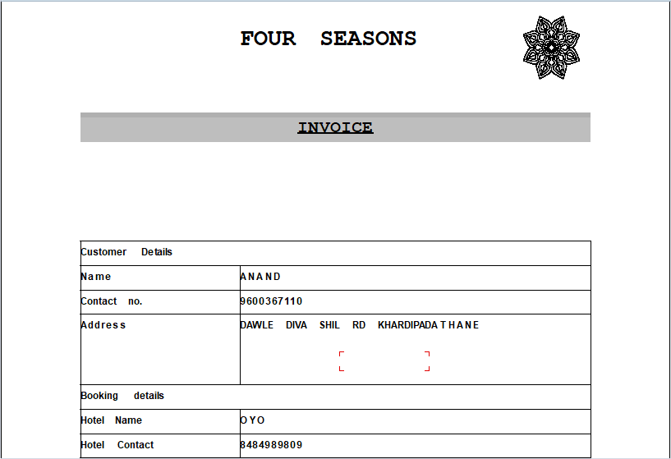

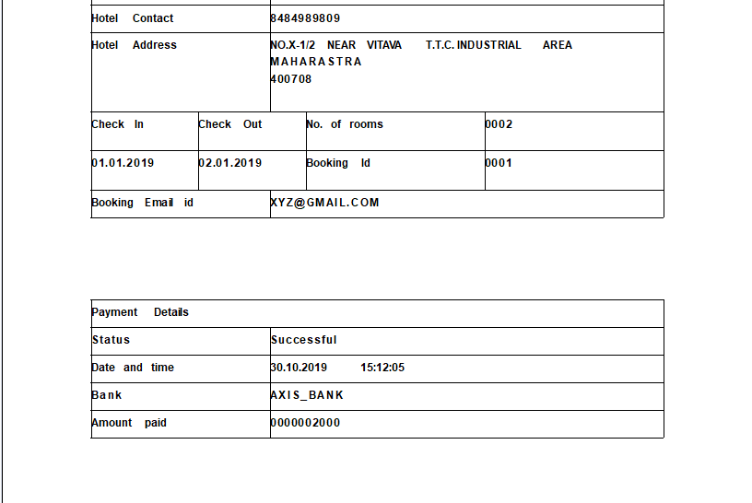

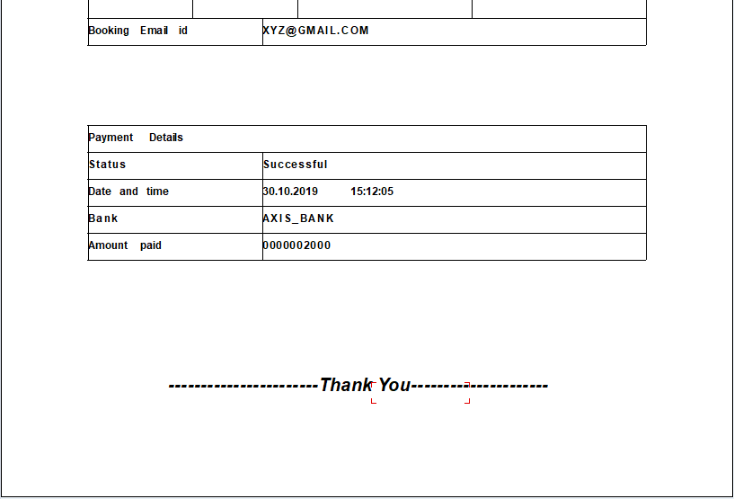

The alv for booking details is:

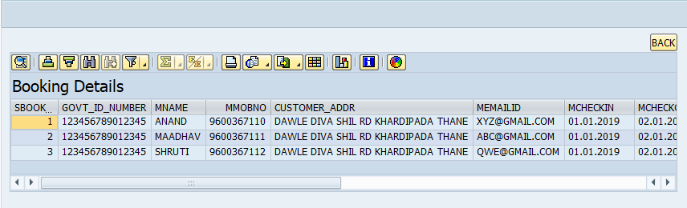

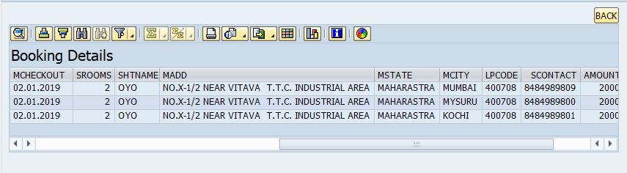

Login screens:

After welcome screen

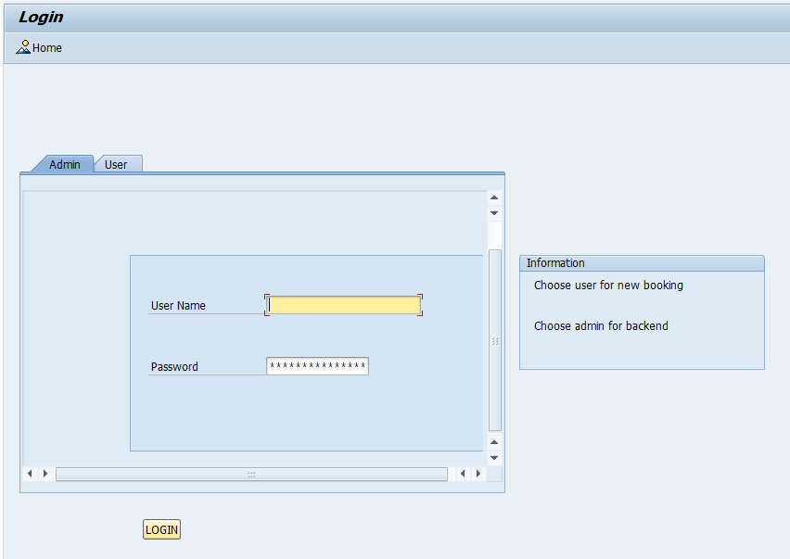

User chooses accordingly and proceeds for login

For admin the screen redirects to admin screen and for new user it goes to new user screen.

Home -> for routing back to welcome screen.

Screen validation for new user.

TABLES AND STRUCTURES: 